

' I

Republic of the Philippines

Llnnna 9tate l}olptetbnic t!tnibersitp

Province of Laguna

Warm greetings from the LSPU Siniloan Campus!

The Administrative Council of this campus had a meeting on November 04, 2020 on the upcoming virtual celebration of LSPU SC Annual Foundation on December 2&3, 2021 with its theme, "LSPU@69: A Beaconof Hope and Innovation Responding to the Challenges of COVID 19 Pandemic".The purpose of this endeavor

is to commemorate the 69th years of milestones of the LSPU Slniloan since its establishment. Further,this can bea great avenueto inform our newstudents,faculty members and staff on how the university struggles and serve as strong foundation of higher education,training grounds for the professionals, mould and uphold its stakeholders and surpass the pandemic/challenges with utmost integrity, professionalism and

innovation.Moreover,we would like to inform your good office that our Guest of Honor inthis event is Hon.

Emelita P.Bagsit, Regional Director,DOST-CALABARZON.

Further, we would like to request for the followinglineitems for the operations of the workingcommittee inmakingthis virtualfoundinganniversary a reality, to wit: (1.) Budgetary requirements and other operating expenses for this purpose;(2.) Venue for the recording; and (3.) Equipments for editing and viewing of the

videos.

Attached herewith are proposed program and the breakdown of expenses for your perusal. Thank you very much for the trust that you have entrusted to this campus. We are hoping for your favorable response on this matter.

RespeY.ours,

# JAYSON LAYTA, MRD

*In charge,* PU @ 69 & OSAS Director

Funds Available:

# MARIE AMMA'- i CABILDO

Director *for Flna e*/Budget *Officer*

RecommendingApproval :

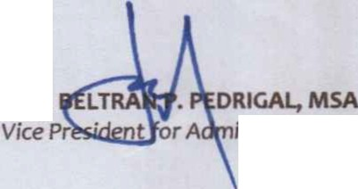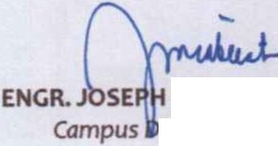

# M. CABIENTE, MBM, MSME



*irector, Siniloan campus*

# ENGR.

*inistration*

VJIVD•n ONES, EdD

*Univ* sity *President, LSPU*

*Vice-Chafrper* n,*LSPU Board of* Regents *(BOR)*

*Rl_ 69'h lSPU·SC Virtual Founding Anniversary,page _*



*LSPU·OSAS·RL -J2L*£, *R.O August 10,2016*